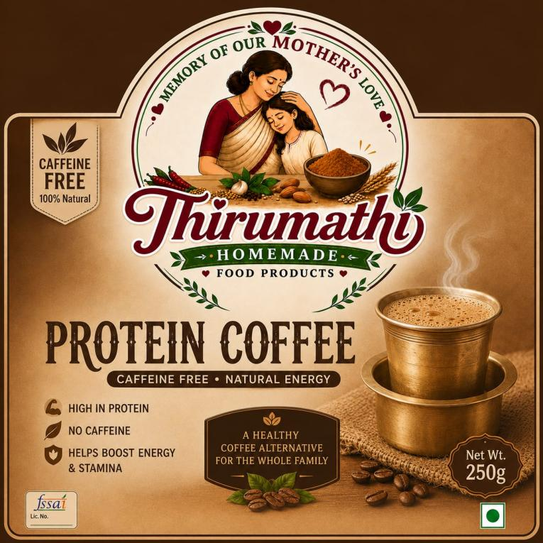
Thirumathy Homemade Protein Coffee 100GM RS 80
Thirumathy Homemade Protein Coffee is a caffeine-free, natural energy drink alternative packaged in a 100g net weight pouch.
How to Use:
- Add 2 teaspoons (10–15 g) of Protein Coffee powder to a cup.
- Pour 150–200 ml of hot milk (or hot water if preferred).
- Stir well until completely dissolved.
- Add jaggery, palm sugar, or sugar to taste (optional).
- Drink once or twice daily, preferably in the morning or evening.
Serving Suggestion for the Label:
How to Use
- Mix 2 tsp (10–15 g) in 150–200 ml hot milk or hot water.
- Stir well.
- Sweeten as desired.
- Serve hot.

Thirumathy Multi Traditional Rice Puttu (250 g) RS 100

How to Use
- Take 1 cup (100 g) of Puttu Mix in a bowl.
- Add 2 cups (400 ml) of water gradually while stirring to avoid lumps.
- Cook on medium flame for 5–7 minutes, stirring continuously until soft and thick.
- Serve hot with grated coconut, banana, jaggery, sugar, or curry as desired.
Cooking Ratio:
1 Cup Puttu Mix : 2 Cups Water
Note: If this product is truly an instant "No Steaming • Ready to Eat" mix, then the current instruction on the package ("2 cup water to 1 cup puttu") may be misleading. If it only needs mixing with hot water and no cooking, let me know the exact product type, and I can provide the correct instructions for the label.

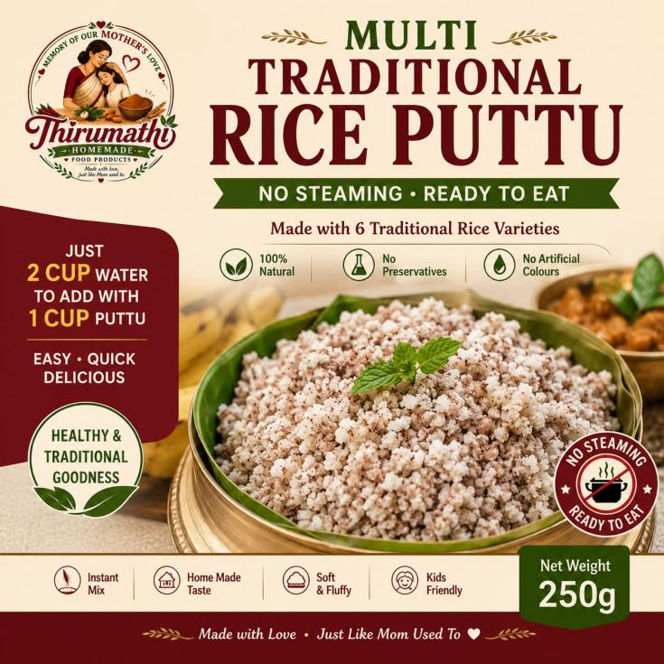

Nutri Fruit Malt100g 110rs
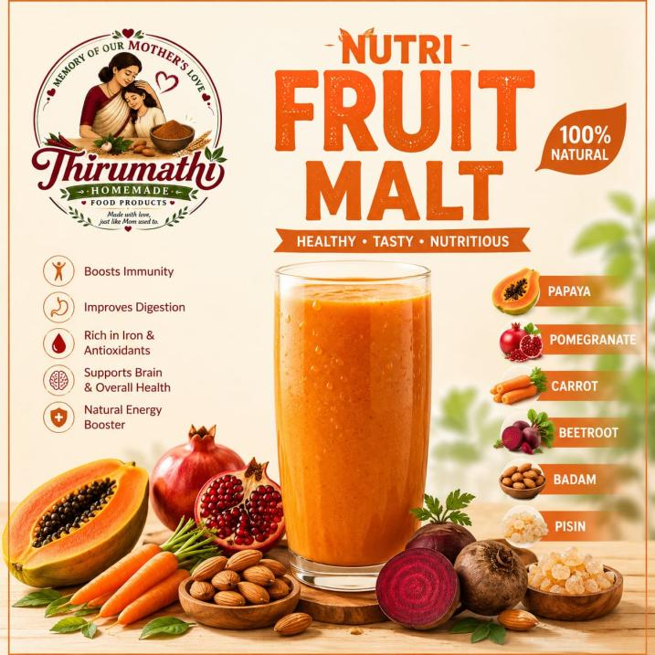
Nutri Fruit Malt appears to be a health drink mix. A simple way to use it is:

How to Use
- Take 2–3 tablespoons (20–25 g) of Nutri Fruit Malt.
- Add it to 200 ml of milk (hot or cold) or warm water.
- Stir or shake well until fully dissolved.
- Add jaggery, honey, or sugar if you prefer it sweeter (optional).
- Drink once or twice a day, preferably:
  - In the morning with breakfast, or
  - In the evening as a healthy snack.
For children, use 1–2 tablespoons mixed with 150–200 ml of milk.

Thirumathy Weight Loss Kanji Mix 100g 70rs

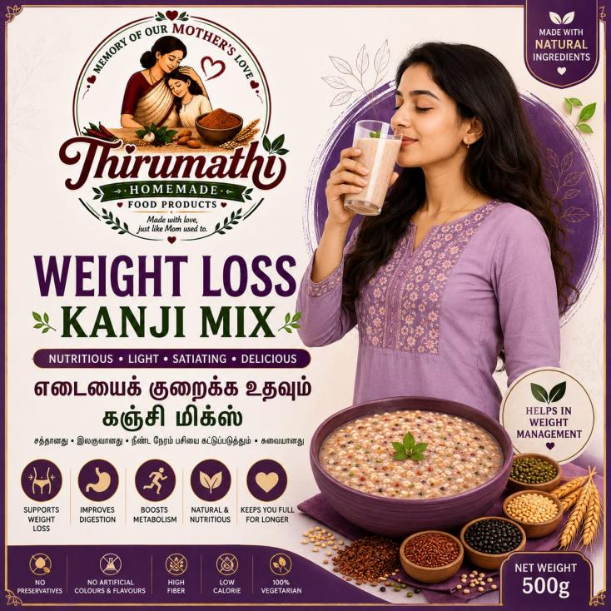

here is a simple way to use it:
- Add 2–3 tablespoons (25–30 g) of Kanji Mix to 250–300 ml of water.
- Stir well so there are no lumps.
- Cook on medium flame for 5–10 minutes, stirring continuously until it becomes a smooth porridge.
- Add salt (for a savory version) or jaggery/palm jaggery (for a sweet version), according to your taste.
- Serve warm.
For weight management:
- Drink 1 bowl as breakfast or replace dinner with it.
- Avoid adding sugar.
- Pair it with a balanced diet and regular exercise.
- Drink plenty of water throughout the day.

Thirumathy Dates Powder 100 g 100rs
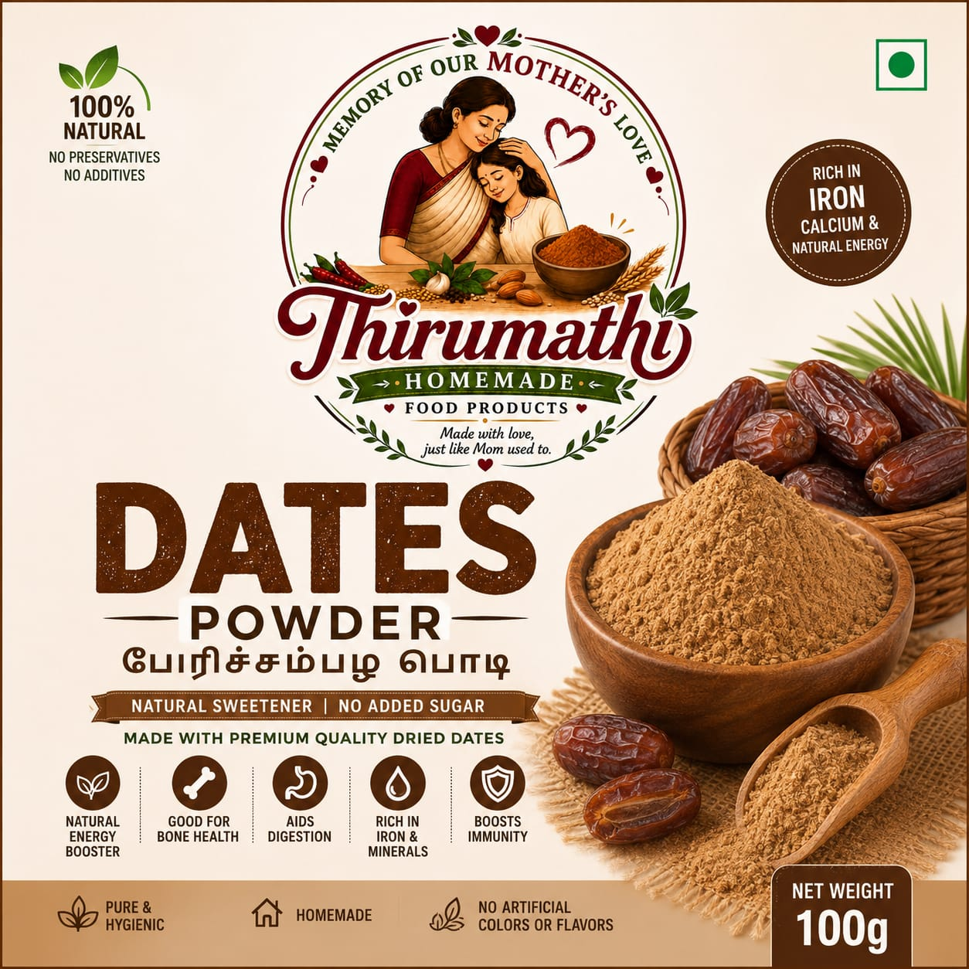
here's how to use it:

How to use Dates Powder
Option 1: With milk (most common)
- Add 1–2 teaspoons (5–10 g) of dates powder to 1 cup (200 ml) of warm milk.
- Stir well and drink.
- Since it is a natural sweetener, you usually don't need to add sugar.
Option 2: With warm water
- Mix 1–2 teaspoons in 1 cup of warm water and stir well.
Option 3: In foods
You can also add it to:
- Porridge or kanji
- Oats
- Ragi malt
- Smoothies and milkshakes
- Yogurt/curd
- Homemade sweets and dessert

